Project Report:Customer relationship management system

# Abstract:

OpenText's strategic initiative focuses on enhancing sales performance and customer experience through a Customer Relationship Management (CRM) system. By integrating content services with key applications like Salesforce, the company aims to centralize customer data, streamline collaboration, and strengthen governance practices. The Sales Department benefits from task automation, improved insights, and increased productivity with features like a 360-degree customer view and AI-driven information management. Marketing gains deeper customer behavior insights to optimize strategies and drive cross-selling. Customer Service aims to deliver personalized service, streamline content creation, and enhance interactions. This CRM integration across departments highlights OpenText's commitment to elevating sales, improving customer service, and driving revenue growth, positioning the company to provide exceptional services and experiences to its clientele.

# Introduction:

OpenText, a leading provider of information management solutions, has strategically decided to boost its sales performance by implementing a Customer Relationship Management (CRM) system. This strategic initiative involves integrating content services with key business applications like Salesforce to streamline collaboration, accelerate information flows, and strengthen governance practices. The primary goal is to centralize customer data and interactions to enhance coordination between the Sales Department, Marketing Department, and Customer Service and Support. The Sales Department stands to benefit from task automation, improved customer insights, and increased sales productivity through features like a comprehensive 360-degree customer view and AI-driven customer information management.

The Marketing Department at OpenText will leverage the CRM system to gain deeper insights into customer behavior, optimize marketing strategies, and drive cross-selling and upselling of products. By utilizing the CRM system, the Marketing Department aims to tailor campaigns more effectively, segment audiences, and measure the performance of marketing initiatives. This strategic alignment with the CRM system will enable the Marketing Department to make data-driven decisions, enhance customer engagement, and maximize the impact of marketing efforts.

# Functional requests:

The system should allow users to perform the following functions based on the entities and attributes provided:

Customer Management:

Create, update, and delete customer records.

View and search customer information based on Customer ID, Name, Contact Information, Address, Email, and Phone Number.

Contact Management:

Record new contacts between the company and customers.

Track contact details such as Contact Type, Contact Date, and Interaction Details.

Associate contacts with specific customers based on Customer ID.

Lead Management:

Create, update, and delete lead records.

Track Lead Source, Lead Status, and Lead Date for each lead.

Associate leads with specific customers based on Customer ID.

Opportunity Management:

Manage sales opportunities for customers.

Track Opportunity Type, Opportunity Stage, and Expected Revenue.

Associate opportunities with specific customers based on Customer ID.

Account Management:

Manage customer accounts.

Track Account Type, Account Status, and Account Start Date.

Associate accounts with specific customers based on Customer ID.

Sales Details Management:

Record sales transactions.

Track Sales Date, Quantity, and Amount for each sale.

Associate sales with specific customers and products based on Customer ID and Product ID.

Interaction Management:

Record interactions between customer care and clients.

Track Interaction Type, Interaction Date, and Interaction Details.

Associate interactions with specific customers based on Customer ID.

Product Information Management:

Manage product details.

Track Product Name, Description, Price, and Availability.

Associate products with specific sales based on Product ID.

Campaign Management:

Manage marketing campaigns.

Track Campaign Name, Campaign Type, Start Date, and End Date.

Associate campaigns with specific customers based on Customer ID.

Sales Report Management:

Generate and view sales reports.

Track Report Type, Report Date, and Report Details.

Associate reports with specific customers based on Customer ID.

# ER diagram:

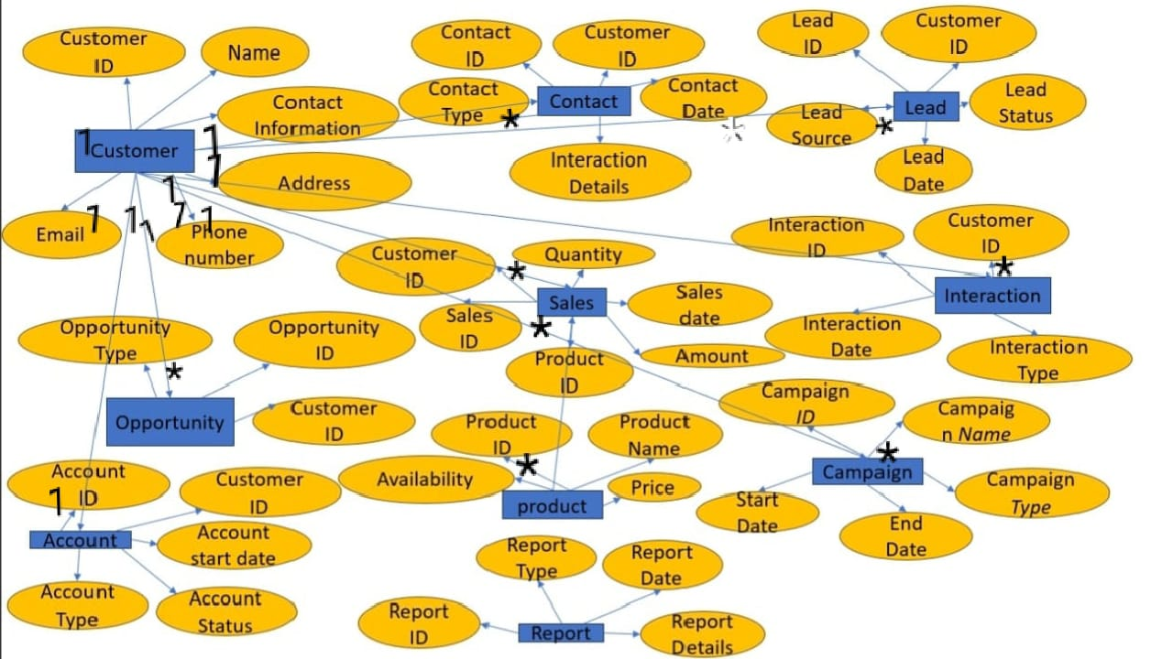

# Summary of entities and attributes:

1.the sales marketing and customer services department takes entity Customer for information Attributes: Customer ID, Name, Contact Information, Address, Email, Phone Number

2. the mode of contact between the company and customer entity Contact. Attributes: Contact ID, Customer ID, Contact Type, Contact Date, Interaction Details

3.the work progress of team is derived from Lead entity: Attributes: Lead ID, Customer ID, Lead Source, Lead Status, Lead Date

4.the Opportunity provided by the company has entity as opprtunity: Attributes: Opportunity ID, Customer ID , Opportunity Type, Opportunity Stage, Expected Revenue

5.Account details entity account: Attributes: Account ID, Customer ID , Account Type, Account Status, Account Start Date

6.Sales details: Attributes: Sales ID, Customer ID , Product ID , Sales Date, Quantity, Amount

7.Interaction between the customer care and client: Attributes: Interaction ID, Customer ID , Interaction Type, Interaction Date, Interaction Details

8.Product information : Attributes: Product ID, Product Name, Description, Price, Availability

9.Campaign of the product campaign as entity: Attributes: Campaign ID, Campaign Name, Campaign Type, Start Date, End Date

10.Report of the sale report as entity : Attributes: Report ID, Report Type, Report Date, Report Details

# Summary relations:

1.Customer - Contact Relationship One-to-Many: A customer can have multiple contacts.

2. Customer - Lead Relationship One-to-Many: A customer can have multiple leads.

3. Customer - Opportunity Relationship One-to-Many: A customer can have multiple opportunities.

4. Customer - Account Relationship One-to-One: Each customer is associated with one account.

5.Customer - Sales Relationship One-to-Many: A customer can have multiple sales transactions.

6. Customer - Interaction Relationship one-to-Many: A customer can have multiple interactions.

7. Product - Sales Relationship Many-to-Many: A product can be associated with multiple sales, and a sale can include multiple products.

8.Customer - Campaign Relationship One-to-Many: A customer can be part of multiple campaigns

# Queries to create database:

**#CREATE DATABASE CMS**

Create database cms;

**#USE DATABASE CMS**

Use cms;

**#Create table Customer**

CREATE TABLE Customer (

CustomerID INT PRIMARY KEY,

FirstName VARCHAR(50),

LastName VARCHAR(50),

Email VARCHAR(100),

PhoneNumber VARCHAR(15),

Address VARCHAR(255),

City VARCHAR(50),

State VARCHAR(50),

ZipCode VARCHAR(10)

);

Select*from customer;

**#Create table Contact**

CREATE TABLE Contact (

ContactID INT PRIMARY KEY,

CustomerID INT,

ContactInformation VARCHAR(255),

ContactType VARCHAR(50),

FOREIGN KEY (CustomerID) REFERENCES Customer(CustomerID)

);

Select*from Contact;

**#Create table Lead**

CREATE TABLE Lead (

LeadID INT PRIMARY KEY,

CustomerID INT,

LeadStatus VARCHAR(50),

LeadDate DATE,

LeadSource VARCHAR(100),

FOREIGN KEY (CustomerID) REFERENCES Customer(CustomerID)

);

Select*from Lead;

**#Create table Opportunity**

CREATE TABLE Opportunity (

OpportunityID INT PRIMARY KEY,

CustomerID INT,

OpportunityType VARCHAR(50),

OpportunityDate DATE,

FOREIGN KEY (CustomerID) REFERENCES Customer(CustomerID)

);

Select*from Opportunity;

**#Create table Sales**

CREATE TABLE Sales (

SalesID INT PRIMARY KEY,

CustomerID INT,

ProductID INT,

SalesDate DATE,

Quantity INT,

Amount DECIMAL(10, 2),

FOREIGN KEY (CustomerID) REFERENCES Customer(CustomerID),

FOREIGN KEY (ProductID) REFERENCES Product(ProductID)

);

Select*from Sales;

**#Create table Interaction**

CREATE TABLE Interaction (

InteractionID INT PRIMARY KEY,

CustomerID INT,

InteractionDate DATE,

InteractionType VARCHAR(50),

FOREIGN KEY (CustomerID) REFERENCES Customer(CustomerID)

);

Select*from Interaction;

**#Create table Account**

CREATE TABLE Account (

AccountID INT PRIMARY KEY IDENTITY(1,1),

Username NVARCHAR(50) UNIQUE,

Password NVARCHAR(255), -- Hashed passwords should be stored securely

CustomerID INT,

CreatedDate DATETIME DEFAULT GETDATE(),

FOREIGN KEY (CustomerID) REFERENCES Customer(CustomerID)

);

Select*from Account;

**#Create table Product**

CREATE TABLE Product (

ProductID INT PRIMARY KEY,

ProductName VARCHAR(100),

Price DECIMAL(10, 2)

);

Select*from Product;

**#Create table Campaign**

CREATE TABLE Campaign (

CampaignID INT PRIMARY KEY,

CampaignName VARCHAR(100),

CampaignType VARCHAR(50),

StartDate DATE,

EndDate DATE

)

Select*from Campaign;

**#Create table Report**

CREATE TABLE Report (

ReportID INT PRIMARY KEY,

ProductID INT,

ReportDate DATE,

ReportType VARCHAR(50),

ReportDetails TEXT,

FOREIGN KEY (ProductID) REFERENCES Product(ProductID)

);

Select*from Report;